Assignment Asset- Scenario

Hotel Escargo Mission Statement

Serve the business and pleasure traveler by making customer satisfaction priority number one through top quality service, amenities, comfortable surroundings, and friendly employees.

Problem Statement

Upon the annual review of the Hotel Escargo chain, it was discovered that there was room for improvement with the check-in and check-out system implemented by the Rooms Division Department. In addition, there are many areas that the hotel can improve to raise the overall quality and customer satisfaction.

The current process used to check guests in and out of the hotel is inefficient for both the customer and the hotel, and a new process must be developed that provides a convenient and efficient experience for the customer, as well as one that makes the best use of the hotel’s resources.

Industry Standards

The following are the process standards by which hotels can gain valuable points and awards like the “Roadster Four Diamond” or the “Touring Association Five Platinum Star Award.”

Check-in procedure:
- Use the guest’s name at least three times.
- Look up to greet the guest and use the phrases “Good morning/afternoon/evening.”
- Acknowledge guests waiting in the line.
- Ask for the guest’s name if not given.
- Retrieve reservation, check the room status, and retrieve registration card.
- Ask for photo ID to verify reservation information.
- Present registration card to guest to verify that the information is correct and ask the guest to sign it.

Confirm the following:

- credit card
- departure date
- room category (bedding, smoking preference, view) and rate Next:
- Inform a bell person.
- Change reservation status to in-house.
- Make and present the keys.
- Wish the guest an enjoyable stay.
Check-in process must be completed in 4 minutes or less.

Check-out procedure:
- Use the guest’s name at least three times.
- Look up to greet the guest and use the phrases “Good morning/afternoon/evening.”
- Acknowledge guests waiting in line.
- Ask for the guest’s name if not given.
- Retrieve reservation, check guest’s account, and retrieve information on credit card expenses.
- Ask for photo ID to verify reservation information.
- Present the bill to the guest to verify that the information is correct, and ask guest to sign for confirmation.

Confirm the following:

- credit card
- departure time

Next:

- Inform a bell person.
- Change reservation status to checked-out.
- Inform Valet or Transportation manager.
- Wish the guest a safe trip.
Check out process must be performed in 2 minutes or less.

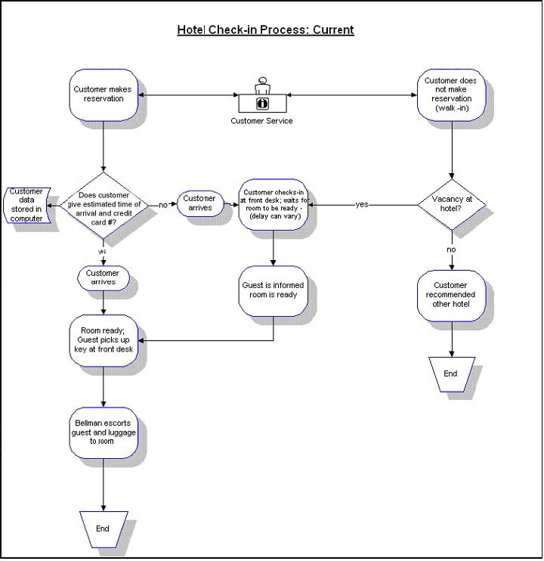

Current Procedures: Hotel Escargo Check-in Process

The check-in process starts when the hotel clerk at the front desk verifies whether or not the customer made a reservation. There are two ways to verify the reservation: reference an ID number OR verify a driver’s license or some other form of ID.

The guest retrieves a key or key card at the front desk. The clerk notifies the bellman if the customer needs help to his/her assigned room. In cases where the room is unavailable due to cleaning or otherwise, the clerk informs the guest of the situation and determines if another equivalent room may be assigned; otherwise, the guest waits. Once the guest is informed that the room is available, the clerk notifies the bellman as required to assist the guest to his/her room. If there is no vacancy, the clerk will contact another hotel as a good faith gesture.

Average Check in Time Hotel Escargo

The average check-in time was measured for guests at Hotel Escargo on July 31 of this year, with results as follows:

Guest Name | Time in Seconds
Weinberg, J | 250
Block, M | 442
Roberts, T | 161
Wolf, B | 397
Nomery, S | 274
Deloach, M | 418
Roth, R | 428
Kleven, J | 456
Young, E | 151
Hannah, C | 490
Anthony, J | 138
Stewart, J | 152
Anderson, Y | 154
Kalu, M | 146
Smith, C | 235
Hartigan, R | 196
Usborne, N | 292
Pratt, J | 464
Harris, R | 364
Ritsema, P | 249
Prince, B | 134
Venter, F | 197
Wassenaar, B | 415
Lennox, S | 507
Jones, H | 432
Harvey, H | 427
Dean, J | 137
Bradley, J | 173
Ruggerio, H | 160
Total | 8439
Average Time | 291.0
Average Time in Minutes | 4 minutes and 51 seconds.

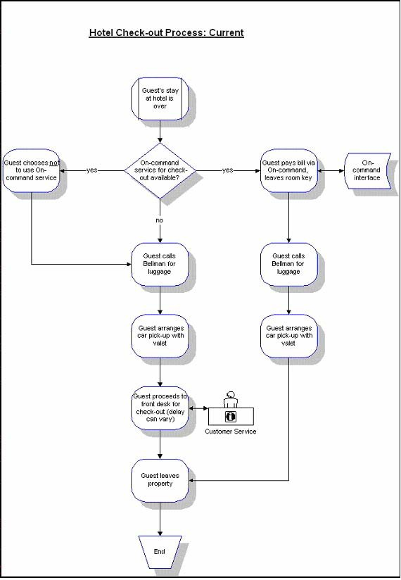

Average Check-out Time Hotel Escargo

The check-out time was recorded for guests on August 1 of this year.

Guest Name | Time in Seconds
O’Hara, K | 228
Belk, D | 233
Rodriguez, C | 100
Yeh, F | 261
Pantazi, R | 188
Hussain, P | 203
Cho, H | 157
Peters, J | 214
Roth, R | 124
Kleven, J | 274
Young, E | 172
Hannah, C | 143
Anthony, J | 221
Stewart, J | 187
Anderson, Y | 228
Kalu, M | 206
Smith, C | 182
Hartigan, R | 117
Usborne, N | 226
Pratt, J | 237
Harris, R | 224
Weinberg, J | 227
Block, M | 128
Roberts, T | 150
Wolf, B | 245
Nomery, S | 190
Deloach, M | 260
Rosenberg, V | 197
Block, M | 188
Matheas, J | 260
Blaum, T | 131
Bloom, A | 206
Total | 6307
Average Time | 197.1
Average Time in Minutes | 3 minutes and 17 seconds.

Current Procedure: Change request

The average time a guest must wait when requesting changes (such as a room move or change of room category) needs to be no longer than six minutes. If extra time was needed to find the right room, the manager on duty would explain the condition to the guest and immediately find another room. Excessive change requests present negative impacts on all departments within the organization and increase the time in assigning a customer to a room. The following are action items implemented when a change request is initiated:

  - Manager on duty has to request housekeeping to clean the room again.
  - Bell desk attendant removes all luggage from the old room and takes it to the new assigned room.
  - In the event that amenities were assigned, a staff member must move the amenities from the original assigned room to the new room.
  - The front desk annotates the changes into the reservation computer network and issues a receipt to the customer.

The change request time was recorded for guests on July 31 of this year.

Guest Name | Time in Seconds
Rosenberg, V | 560
Block, M | 556
Matheas, J | 629
Blaum, T | 520
Allen, D | 702
Cleveland, M | 796
Paris, N | 763
Sanclair, M | 586
Weinberg, J | 474
Block, M | 616
Roberts, T | 487
Wolf, B | 393
Nomery, S | 629
Deloach, M | 732
Roth, R | 584
Kleven, J | 806
Young, E | 720
Hannah, C | 556
Anthony, J | 799
Stewart, J | 789
Anderson, Y | 615
Kalu, M | 472
Smith, C | 400
Hartigan, R | 723
Usborne, N | 622
Pratt, J | 707
Harris, R | 554
Ritsema, P | 729
Harvey, H | 657
Dean, J | 613
Bradley, J | 566
Ruggerio, H | 779
Total | 20134
Average Time | 629.2
Average Time in Minutes | 10 minutes and 29  seconds.

Other Hotel Escargo Services

Other services needing to be reviewed include the following:
    - room service
    - newspaper delivery
    - automated teller machine (ATM)
    - baggage storage
    - beverage area
    - complimentary concierge desk
    - elevators
    - gift shop
    - laundry/valet service
    - local area transportation
    - lounge
    - luggage hold
    - multi-lingual staff
    - news stand
    - safety deposit box
    - shoe shine stand
    - tour desk
    - audio/visual equipment rental
    - business center
    - express mail
    - fax
    - meeting rooms
    - modem
    - notary public
    - photo copying service
    - printer
    - secretarial service
    - video conferencing
    - fitness room
    - cribs

