Organism Physiology: The Collared Peccary
Deborah Mayers
Biology 101
Dr. Doreen Sterling
July 27, 2015

Collared Peccary (Pecari tajacu)
The Collared Peccary, also known as the Javelina in the US Southwest, originated in South America and migrated north into the Southwestern states of North America. According to the Arizona Department of Game & Fish (2015), “the collared peccary has one of the greatest latitudinal ranges of any New World game animal, occurring from Arizona to Argentina…[and] the range of the peccary is still expanding, primarily northwestward” (para. 2).

Evolution of the Collared Peccary
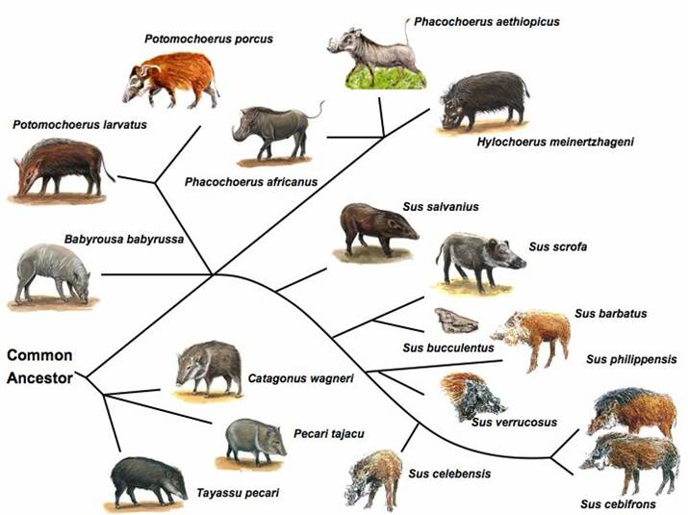
There are over 3000 different species of porcine throughout the world and mapping their evolution and taxonomy can “provide further insight to the contribution of the different kinds of variation” seen across the species (Groenen M. , u.k.). While the Collared Peccary’s branch of the phylogenetic tree is much removed from the domesticated pig, the classification and phylogeny of the Collared Peccary “exhibit[s] fundamental similarities because they evolved from the same structure in a common ancestor” (Simon, Dickey, & Reece, 2013, p. 286).
Growth and Development
The Collared Peccary are diminutive in relation to many of their cousins, weighing in between 35 to 60 lbs. and standing at only a “shoulder height from 20 to 24 inches…their length from head to tail is from 36 to 48 inches” (Ponderosa Images Co., 2008, p. 1). When born Collared Peccary only weigh around one pound and “are tan to brownish in color with a reddish dorsal stripe” (Department of Arizona Game & Fish, 2015, para. 2). It is not until the offspring reach three months of age that they develop the “salt and pepper appearance of adults” which is due to whitish bands on the black hairs” (Department of Arizona Game & Fish, 2015, para. 2). The black hairs are located along the spine of can be “up to six inches long, with the mane being blackest, longest, and erectile” (Department of Arizona Game & Fish, 2015, para. 2).This coloring many have developed in response to the environment and could allow for camoflaush from predators. Another possible purpose of the six inch mane could be that it functions along the same lines as wiskers or feelers that can help navigation or provide warnings.
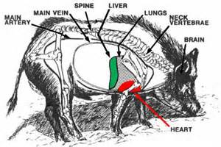
Due to the Collared Peccary’s low center of gravity, their major organs are situated beneath the spine, lower to the ground making the underside of the belly their vulnerability. In addition, with their short legs the danger of being up-ended with their belly exposed would be a weakness that could be exploited by predators. One of the ways that nature has combated this weakness is to provide the porcine species with “the largest repertoire of functional olfactory receptor genes, reflecting the importance of smell” which could provide warnings regarding possible dangers and also allow for the scavenging of food (Groenen & Archibald, 2012, para. 1).
Reproduction
The Collared Peccary reach maturity in around 10 months and are ready to produce offspring (Department of Arizona Game & Fish, 2015, para. 3). Their reproduction cycle is year round with a incubation period of “140 to 150 days and they average giving birth to 2 young, but sometime they do have 3” (New Hamphire Public Television, 2015, para. 2). In Darwin’s theory of natural selection he denotes “that all species tend to produce excessive numbers of offspring” (Simon, Dickey, & Reece, 2013, p. 252). In this venue it is possible that the Collared Paccary adapted to a high offspring mortality rate with an early development rate and also by being able to breed all year long. This provided them the “ability to have two litters in one year [which] gives them the greatest reproductive potential” (Department of Arizona Game & Fish, 2015, para. 3).
Environment
Collared Peccary have a “geographical distribution from Arizona to Argentina” (Silva, de Freitas, & Sbalqueiro, 2009, p. 1) and can roam over a territory as large as 1000 to 2000 acres (New Hamphire Public Television, 2015, para. 2). The Collared Peccary group together in herds consistent of anywhere from 5 to 50 animals and establish their territories by “using droppings and the dorsal scent gland to mark these areas” (Department of Arizona Game & Fish, 2015, para. 3). Because their territory can cover a wide variety of ecosystems their diet varies and can include, “prickly pear cactus, fruit, nuts, seeds, succulents and garbage” (Ponderosa Images Co., 2008, para. 4).
In the wild, Collared Peccary can live up to 10 years and even longer in captivity (Ponderosa Images Co., 2008, para. 3). Due to the demand for leather goods and food products in South America many are relegated to breeding farms where genetic variability can be limited. Because of these farms the population of Collared Peccary have exhibited “excess homozygosity” (Silva, de Freitas, & Sbalqueiro, 2009, p. 5), effectively pushing this group into a genetic drift or causing founders effect.
In a study published by the Sociedade Brasileira de Genetica (2009), Silva, de Freitas and Sbalqueiro observed that a “reduction from the original species can vary widely”, which could be caused by one herd not interbreeding with another “thereby promoting endogamy and the founder effect” (Silva, de Freitas, & Sbalqueiro, 2009, p. 4). Other possible explanations of the limited genetic variability “could be related to the presence of null alleles” or “since the capitive populations were artificial and recently formed” they did not have enough time for “self-structuring” (Silva, de Freitas, & Sbalqueiro, 2009, p. 4).
Conclusion
It is clear from research that the Collared Peccary has evolved and adapted to their environment and become a viable organism in its varied ecosystems. This is consistant with their cousins of the porcine family who also show their adaptability in a multitude of environments. It seems that this creature has the ability to continue to evolve whether independently or through human intervention as their ecosystem changes in the future. However, I fear that their wild brothers and sisters will not fare as well as the ones in captivity due to loss of habitate as humans intrude on their territories.

References
Department of Arizona Game & Fish. (2015). Javelina. Retrieved from Department of Arizona Game & Fish: http://azgfdportal.az.gov/hunting/species/biggame/javelina
Groenen, M. A., & Archibald, A. L. (2012, November 14). Analysis of pig genomes provide insight into procine demography and evolution. Retrieved from Nature: http://www.nature.com/nature/journal/v491/n7424/full/nature11622.html#author-information
Groenen, M. (u.k.). SelSweep: Molecular characterization of genetic factors in the pig under selection during speciation, domestication ad breeding. Retrieved from Wageningen University: www.quantomics.eu/.../1.4_overview_selsweep.pdf
New Hamphire Public Television. (2015). collared Peccary - Pecari tajacy. Retrieved from Nature Works: http://www.nhptv.org/natureworks/peccary.htm
Ponderosa Images Co. (2008). Javelina Family Life: An Educational Wildlife Documentary. Retrieved from Javelina Family Life.com: http://www.javelinafamilylife.com/about-javelinas.shtml
Silva, R. W., de Freitas, T. R., & Sbalqueiro, I. J. (2009, July 1). Evaluatio of genetic variability in the collared peccary Pecari tajacu and the white-lipped peccary Tayassu pecari by microsatellite markers. Retrieved from Genetics and Molecular Biology Online Ahead of Print: www.sbg.org.br
Simon, E. J., Dickey, J. L., & Reece, J. B. (2013). Campbell Essential Biology with Physiology, 4th edition. Benjamin Cummings.
The Pig Site News Desk. (2010, March 1). New Study on Evolution of Pigs. Retrieved from The Pig Site: http://www.thepigsite.com/swinenews/23243/new-study-on-evolution-of-pigs/

Footnotes
1[Add footnotes, if any, on their own page following references. For APA formatting requirements, it’s easy to just type your own footnote references and notes. To format a footnote reference, select the number and then, on the Home tab, in the Styles gallery, click Footnote Reference. The body of a footnote, such as this example, uses the Normal text style. (Note: If you delete this sample footnote, don’t forget to delete its in-text reference as well. That’s at the end of the sample Heading 2 paragraph on the first page of body content in this template.)]

Tables
Table 1
[Table Title]
Column Head | Column Head | Column Head | Column Head | Column Head
Row Head | 123 | 123 | 123 | 123
Row Head | 456 | 456 | 456 | 456
Row Head | 789 | 789 | 789 | 789
Row Head | 123 | 123 | 123 | 123
Row Head | 456 | 456 | 456 | 456
Row Head | 789 | 789 | 789 | 789
Note: [Place all tables for your paper in a tables section, following references (and, if applicable, footnotes). Start a new page for each table, include a table number and table title for each, as shown on this page. All explanatory text appears in a table note that follows the table, such as this one. Use the Table/Figure style, available on the Home tab, in the Styles gallery, to get the spacing between table and note. Tables in APA format can use single or 1.5 line spacing. Include a heading for every row and column, even if the content seems obvious. A default table style has been setup for this template that fits APA guidelines. To insert a table, on the Insert tab, click Table.]

Figures

Figure 1. [Include all figures in their own section, following references (and footnotes and tables, if applicable). Include a numbered caption for each figure. Use the Table/Figure style for easy spacing between figure and caption.]
For more information about all elements of APA formatting, please consult the APA Style Manual, 6th Edition.

